FACS ARIA III Sorting

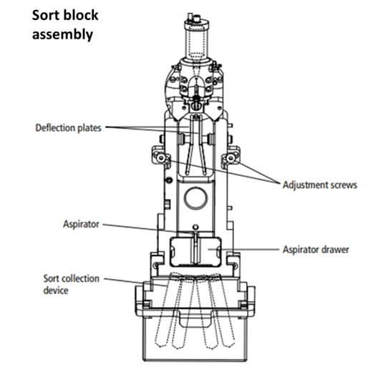Adjust the stream

1. Open the stream
2. Adjust the position of the sort block if the stream is not in the center
3. Set drop #1 position on the upper third part of the stream window by roughly adjusting the Ampl value. Keep the Ampl within 8-60 range.

|  |  |  |  |  |
| --- | --- | --- | --- | --- |
| Nozzle size (um) | 70 | 85 | 100 | 130 |
| Desired gap value | 6-7 | 10-12 | 14-18 |  |

1. Set Gap size
2. **Rotate the handle** to get the brightest illumination of the stream.
3. Do test sort (**voltage + test sort**) just to check if the 4 side streams and the central stream look good. If not change the Amp up or down a bit until you get 4 side streams nice and round. If the central stream shape is oval and not round correct the **2nd drop** until it is fixed.
4. Copy the actual drop 1 position from the gray field to the white target value field
5. **Turn on sweet spot**

Drop delay calibration with Accu-drop beads

**On sweet spot**

1. Vortex the accudrop beads. Put 1 drop in 1.5 ml PBS, vortex.
2. Open Acc program
3. Install density filter size 1. Ensure the upper Aria lid is closed!
4. Load – adjust the rate (between 1 to 5) to be 800-2000 ev/sec.
5. Open sort layout
6. **Add** in sort window **P1** to the left. Precision **Fine Tune**.
7. Open **voltage + optical filter**. Wait to see 100% is in the right square.
8. Open left center slider ~28
9. **Start** sort, choose **cancel** to the pop-up question. Sorted beads will go to the waste.
10. Wait until the sort is stabilized. If in the left square you have more than 95% you can stop the sort and unload the beads.  
    If not. Perform auto-delay. This automatic program will take a few minutes. When it finished press **Exit** and stop the sort by pressing **Pause** on the sort layout window and **Unload** the sample. (no need to save the sort)

Test Sort

Adjust side streams into tubes:

1. Insert 4 or 2 tubes to the proper collection adapter
2. Lift up the lid of the Aria. Open sort block assembly cover and look down on the side streams.
3. The initial recommended drop positions in 4 streams setting is: 80-30-30-80 in the voltage sliders
4. **Voltage** (high voltage, be careful!)**-> Test sort -> waste drawer**

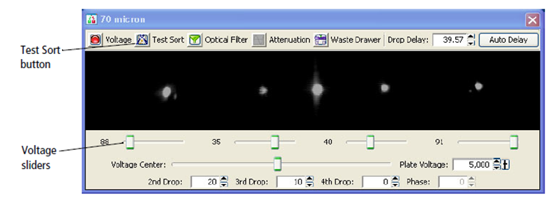

Once you click to open the waste drawer, the sorted drops will start to sort into the collecting tubes.

1. If sorted drops are not aligned to the center of the tubes, move each curser right or left in order to maintain a defined and safe distance between the drops.
2. Once sorted drops are aligned, close voltage and waste drawer.

Opening a new sort experiment

1. Experiment 🡪 syringe 🡪tube
2. Leave only parameter you need – FCS, SSC (linear, A, H, W), Fluorophores (log)
3. Create dot plot and histogram graphs.
4. Draw gates, show population hierarchy.
5. Mark the tube you want to sort into.
6. Create **new sort layout** (blue icon)
7. Inside the window that you have opened choose:

**Device** > 4 tubes or 2 tubes   
**Precision** > 4-way purity (for 4 tubes) or purity (for 2 tubes) or yield (if yield is the most important)   
**Target events** > Continuous or the number you want to collect   
**Save sorted reports** > Ask user.

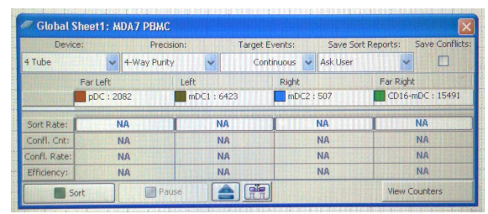

6. Decide for each sort channel what cellular population in going to be sorted into it by clicking on the name of the sort channel and choosing a certain population

*** Pay attention to the fact that the software supports sorting only up-to 10 gates following gates would not be shown in the sorting list. ***

7. After positioning of the sorting tubes you can start sorting by clicking the **'Sort'** button. The software asks whether to put the waste drawer in sort position, click **'Yes'**.

8. In order to stop sorting, click **'Stop'**.

9. Optional: Load the sorted tubes to check if the right population was sorted and the % purity.

Multi well Plates or slides sort

1. **Sort** 🡪 **home device**
2. Choose the plate size (96 well plate)
3. **Go to home**
4. Insert a plate – A1 should be on the left corner
5. Open far left on ~30 (check in **Test sort** the exact position of the hole in the plate adaptor)
6. Open **voltage** 🡪 **waste drawer** 🡪 short click **test sort**
7. Manipulate plate with arrows to the right position
8. **Set home** 🡪 **apply**



96 well sort – single cell sort

1. Open **sort layout** –> 96 well,
2. **Precision**🡪 **single cell**
3. Choose the wells to sort into
4. **Add** gates to the wells
5. When ready click **acquire** 🡪 **sort** 🡪 remove plate lid 🡪 **ok**.